Feature and Template Fusion Matching Techniques for Estimating Conversion Relationship between GOCI-II L1B Data

Seunghwan Song¹, Han-gyeol Kim¹, Young-Eun Jeon¹, Jae-In. Kim², Sooahm Rhee¹

¹ Image Engineering Research Center, 3DLabs Co. Ltd., Republic of Korea
– (bnb422, khanai, yeun1029, ahmkun) @3dlabs.co.kr
² Korea Aerospace Research Institute, Republic of Korea – jikim@kari.re.kr

The GEO-KOMPSAT-2B is satellite of the Republic of Korea that was launched in 2020 with 10 years mission life and is still performing its mission. Inside, the GOCI-II (Global Ocean Color Imager-II) payload performs segmented shooting to secure a wide shooting area and has several shooting modes depending on the target area. At the same time, as it is a payload for marine observation, it provides information on marine disasters, and various marine environment images. As monthly/seasonal/annual analysis of various marine phenomena and marine thematic maps are made using these outputs, the importance of geometry is very high because specific images must be located in accurate ground coordinates every time. However, the provided L1B image confirmed that there is geometic error between data at different times, and there is a possibility be limitations such as not being able to use time series data in comparison analysis of marine output data in the future, so it is necessary to correct the geometric error according to the reference image.
In this paper, we propose a feature and template fusion matching technique for estimating the conversion relationship between GOCI-II L1B data. The proposed method is area-based matching method, can be divided into the following steps. First, a feature point extraction process is performed on the target image. At this time, Oriented FAST and Rotated BRIEF (ORB) was used as feature point extraction algorithm. In the second step, generate a small template patch area in the target image based on the extracted feature points. In the third step, generate an ROI region in the reference image using the feature point coordinates of the target image extracted in the first process. In the fourth step, a matching point is obtained through Area-based image matching and subpixel positioning using the generated template patch area and ROI area. Finally, the matching point is determined by restoring the coordinates to the original coordinate system and removing the mismatch point. The feature point-based method extracts feature points from each image, calculates descriptors at the corresponding points, and compares and matches them with each other. Differently, the applied area-based method is a method of extracting feature points from only one image, generating a patch image centered on them, and matching them through similarity measure in the search area set in the other image. For this reason, the area-based method requires more processing time, but if the search area can be properly reduced, it can lead to not only the time required but also the improvement of accuracy.
To verify the proposed method, an experiment was conducted using reference image with five L1B images that completed geometric correction and 11 different images taken at various times. Through experiments, it was confirmed that the geometric error was corrected to 0.3 (~ 0) pixels if it was about 0.7 (~ 0.5) pixels. As a result, the possibility of calculating the conversion relationship between L1B images using the matching points derived by the proposed method was confirmed. This method is expected to contribute to the field of marine satellite utilization, and based on these results, geometric correction study of GOCI-II L1B images will be conducted in the future.

Key Words: GOCI-II, Calibration, Feature•Template Matching
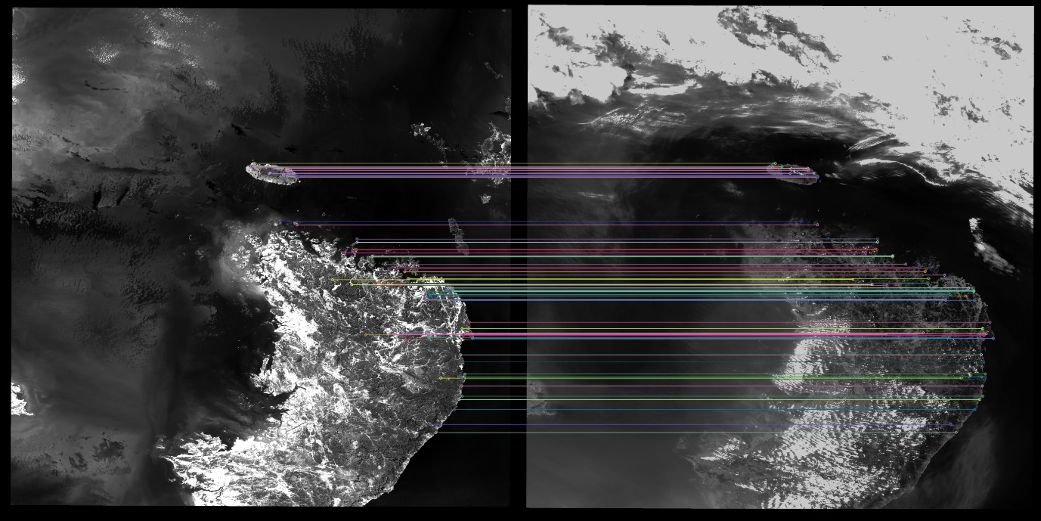
Figure 1 Matching results between Reference Image (Left) and L1B Image (Right)

ACKNOWLEDGEMENTS

This research was supported by Korea Institute of Marine Science & Technology Promotion (KIMST) funded by the Ministry of Oceans and Fisheries (20210046).

